**Game studio management system**



**Session 2023 – 2027**

**Submitted by:**

Muhammad Omer (2023 – CS - 68)

**Supervised by:**

Miss Maida

Course: CSC-102 Programming Fundamentals

Department of Computer Science

**University of Engineering and Technology**

**Lahore Pakistan**

Description of project:

I want to create a game studio management system. It can be used to manage a game studio. You can use it to give tasks to your employees and the employees can use it to keep track of their deadlines and workload.

Users of Application:

The program will have three users:

1. Admin
2. Programmer
3. Game Artist

Functional Requirements:

|  |  |
| --- | --- |
| **User** | **task** |
| Admin | Add tasks |
| Admin | Remove tasks |
| Admin | Preview task completion |
| Admin | View employee attendance |
| Artist | Clock in |
| Artist | Clock out |
| Artist | View given tasks |
| Artist | Mark task as done |
| Programmer | Clock in |
| Programmer | Clock out |
| Programmer | View given tasks |
| Programmer | Mark task as done |

WireFrames:

Login screen:

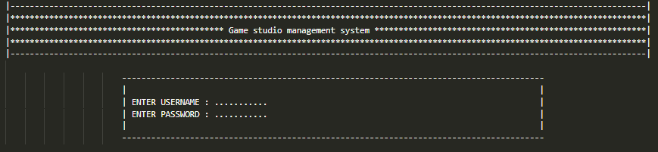

Admin screen:

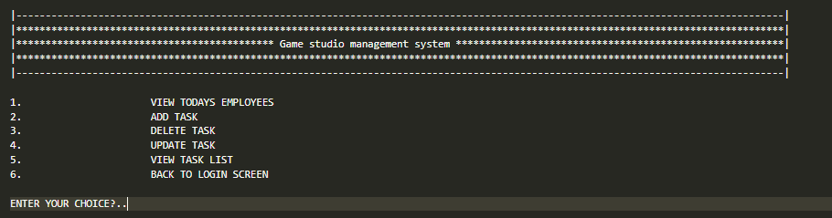

Employee screen

